1180 White Horse Road  Voorhees, NJ 08043  (856) 627-5858 x1134  (856) 566-1937 Fax | Voorhees Township Police Department

Press Release 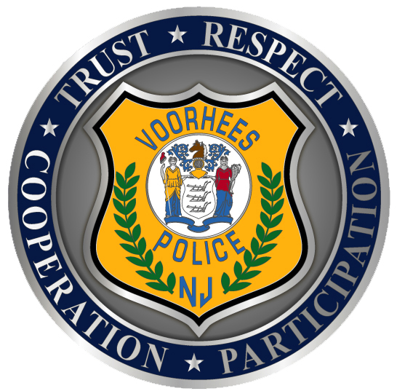

Contact: Captain Carmen Del Palazzo PIO
Telephone: 856-882-1134
Email: cdelpalazzo@vtpd.com

Residential Apartment Fire

VOORHEES TWP. NJ 5/13/15; at 9:48 am, Voorhees Police were dispatched to the 296 Building of Echelon Road for an apartment fire that quickly spread. Arriving Officers evacuated the involved and surrounding units. As police secured a perimeter, the fire was suppressed by Voorhees Fire District along with mutual aid from Cherry Hill, Gibbsboro, West Berlin, Lindenwold, Laurel Springs & Somerdale.

At this time, 10 families have been displaced until Township Engineers can determine the structural integrity of the building and utilities restored. The Red Cross and building management are working to provide placement. The Camden County Fire Marshall, Camden County Prosecutors Office and Voorhees Detectives are investigating to establish the cause. There were no reported injuries to residents nor emergency personnel, however a dog did perish from the fire.

For more information about this topic, please contact Captain Carmen Del Palazzo.

